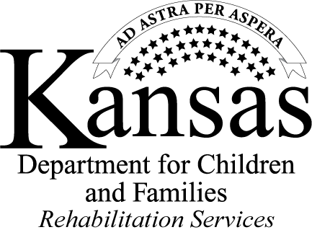
East Region High School Referral
for Pre-Employment Transition Services

Please send completed referral to Talia Bayer Talia.Bayer@ks.gov or fax 785-291-3329
To be completed by high school
From: School ___________________________________________________________
Address/County ___________________________________________________________
School District#/Building Name ___________________________________________________________
Phone ___________________________________________________________
Name/Position Title ___________________________________________________________
Email Address ___________________________________________________________
Student: Name ___________________________________________________________
Address ___________________________________________________________
City/State/Zip Code ___________________________________________________________
County ___________________________________________________________
Phone ___________________________________________________________
Birth Date ___________________________________________________________
Expected Date to complete
or exit high school ___________________________________________________________
Referral Accompanied by: Signed release of information ☐ and IEP ☐ or 504 Plan ☐
To be completed by Student, Parent/Legal Guardian (if applicable)
Best time to schedule a meeting: _______________________________________________________________________

Pre-Employment Transition Services:
Which services are you interested in?
_____ Job exploration counseling  _____ Work-Based Learning Experiences  _____ Instruction on self-advocacy | _____ Counseling on opportunities for enrollment in comprehensive transition or postsecondary education programs  _____ Workplace readiness training to develop social skills and independent living skills

Consent for referral/release of information on back of page, please review and sign
Not an application for Vocational Rehabilitation (VR) Services
CONSENT FOR REFERRAL/RELEASE OF INFORMATION
Below is the signature authorization for ____________________________________ to be referred for Pre-Employment Transition Services (Pre-ETS), Program of Kansas Rehabilitation Services (RS) with the Department for Children and Families (DCF). I consent to the release of the information about me to be sent to RS for purposes of Pre-ETS and the school to discuss planning and service delivery.
Signature of Student ________________________________________________________Date___________________

Signature of Parent/Legal Guardian ____________________________________________ Date___________________
Print Name of Parent/Legal Guardian ___________________________________________
If signed by parent/legal guardian (if applicable), please provide address and phone number if different than the student’s.

Address: __________________________________________________________________________________________
Phone: __________________________________________________________________________________________
Email: __________________________________________________________________________________________
Auxiliary Aids needed: ____________________________________________________________________________
(Examples: Braille, Large Print, Sign Language Interpreter)

